**DATA ANALYSIS WITH COUNOS**

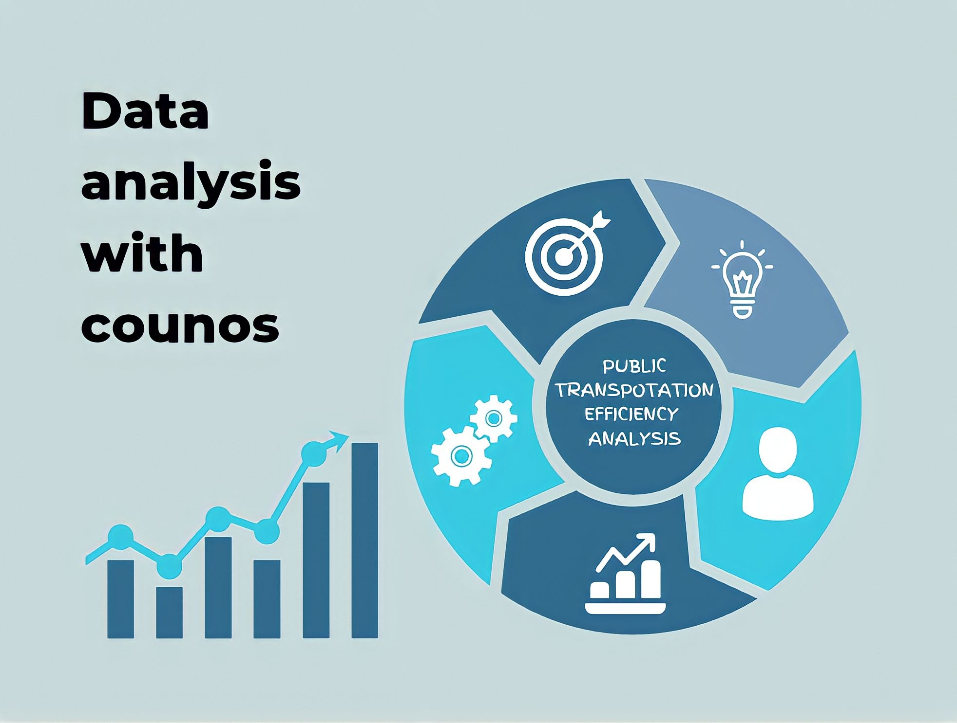

**Introduction:**

Public transport systems play a pivotal role in urban mobility, offering an efficient and sustainable means of transportation for millions of people daily. Analyzing data related to public transport is essential for improving the efficiency, accessibility, and overall quality of these systems. In this report, we will delve into the realm of data analysis in public transport, exploring the critical design features and methodologies that enable us to gain insights and make informed decisions. By harnessing the power of data, we aim to address the challenges and opportunities inherent in public transport, ultimately striving for a more convenient and sustainable urban future.

***1. Data Collection:***

Effective data analysis starts with comprehensive data collection. In the context of public transport, data can be collected from various sources, including ticketing systems, GPS tracking, passenger surveys, and sensor-equipped vehicles. Collecting data in real-time enables a holistic understanding of the system's dynamics, helping in the identification of bottlenecks and opportunities for improvement.

**2. Data Integration:**

Public transport data often comes from disparate sources. Designing data integration mechanisms that combine data streams from buses, trains, trams, and stations is crucial. This integration ensures a unified dataset that can be analyzed cohesively, providing a more accurate picture of the entire system.

***3. Predictive Analytics:***

Public transport analysis benefits from predictive analytics, which allows for forecasting demand, optimizing routes, and improving service reliability. Machine learning algorithms can predict ridership trends, helping transport authorities allocate resources effectively and reduce operational costs.

***4. Network Visualization:***

Designing visual representations of the public transport network can aid in understanding the system's complexity. Network diagrams, geographic information systems (GIS), and interactive maps can help stakeholders visualize routes, interchanges, and congestion points, fostering better decision-making.

***5. Performance Metrics:***

Public transport analysis relies on the definition and monitoring of key performance metrics. Metrics such as on-time performance, ridership growth, passenger satisfaction, and environmental impact are essential for evaluating the success of public transport systems and informing policy decisions.

**Conclusion:**

In conclusion, data analysis plays a vital role in the optimization and improvement of public transport systems. By embracing a data-driven approach, transport authorities can enhance the efficiency, accessibility, and sustainability of their services. The design features mentioned, including data collection, integration, predictive analytics, network visualization, and the establishment of performance metrics, serve as the foundational elements of a successful public transport analysis framework. As cities grow and the demand for efficient transportation options increases, data analysis will continue to be a cornerstone in shaping the future of public transport, ensuring that it remains a viable and attractive choice for urban mobility.